**Practice Schema Readme**

This is the practice exercise for designing database schema, generating DDL scripts for database schema

Tables, populating data for each tables, and using SQL (select, DDL, DML, and TCL).

**OPTION 1: (If you have installed Database on your laptop/desktop)**

**Step 1:**

Create database schema design using Oracle Data Modeler. Follow the document **"Class_Exercise_Logical_Model"** in “Practice Tutorial” folder.

**Step 2:**

Connect to database as SYSTEM user, and create user with following syntax, replace asp13 with your net id.

CREATE USER CSGY6083B_asp13 IDENTIFIED by asp13123

DEFAULT TABLESPACE SYSTEM

TEMPORARY TABLESPACE TEMP

ACCOUNT UNLOCK;

GRANT CREATE SESSION, DBA TO CSGY6083B_asp13;

**Step 3:**

Download STUDENT_SCHEMA_SETUP_ORACLE.SQL, placed in “Practice Tutorial” folder. Modify AP_ to your initial_. E.G. if your initial is YW, then replace AP_ to YW_ in this file.

Connect to database as GC3500_asp (your login account).

Run STUDENT_SCHEMA_SETUP_ORACLE.SQL, in your login schema

**Step 4:**

**Practice on SQLs from following documents, posted in Practice Tutorial folder**

SQL_TUTORIAL.docx

Oracle_ROLLUP_CUBE_Examples.docx

Oracle_Analytics_Function_Examples.docx

**OPTION 2: (If you want to practice on Oracle Live SQL website)**

**Step 1:**

Create database schema design using Oracle Data Modeler. Follow the document **"Class_Exercise_Logical_Model"** in “Practice Tutorial” folder.

**Step 2:**

Download STUDENT_SCHEMA_SETUP_ORACLE.SQL, placed in “Practice Tutorial” folder to your local laptop/desktop. Modify AP_ to your initial_. E.G. if your initial is YW, then replace AP_ to YW_ in this file.

**Step 3:**

Login to livesql.oracle.com using your oracle account and perform following steps

Click on **"My Script"** on left side menu

Click on **"Upload Script"** ,then click on **"Choose File"** and select

"STUDENT_SCHEMA_SETUP_ORACLE.SQL" from yourfolder where you have

downloaded.

Type **"Script Name"** as **"MY_PRACTICE_SCHEMA"**

Type description as **" This is practice schema"** and then click on **“Upload Script”**

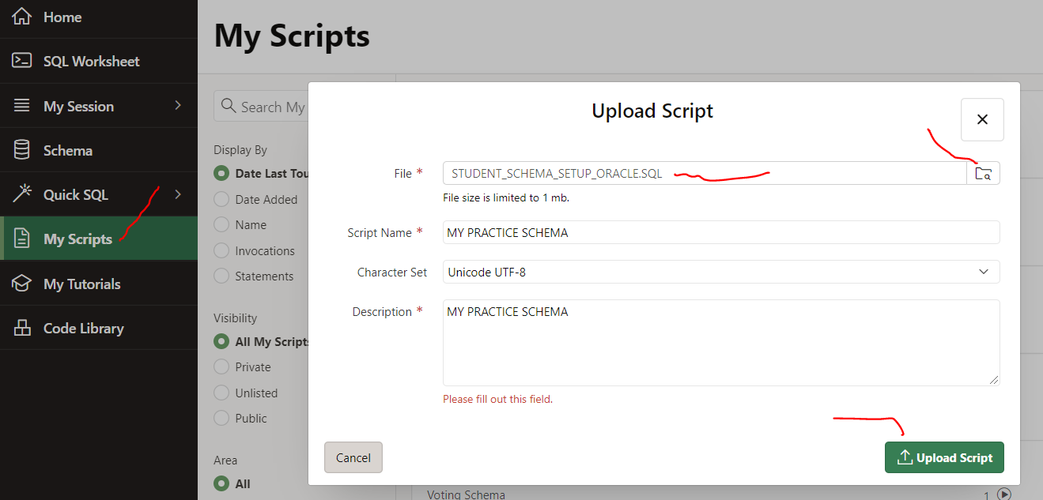

**Step 4:**

Once script is uploaded, click **“Run Script”**

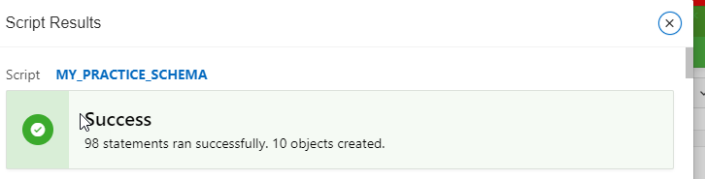

**IF YOU HIT FOLLOWING ERROR, JUST CANCEL IT, WAIT FOR ABOUT 15 MINUTES, AND THEN CHECK SCHEMA THAT ALL TABLES CREATED, AND THEN CHECK NUMBER OF RECORDS FOR EACH TABLE.**

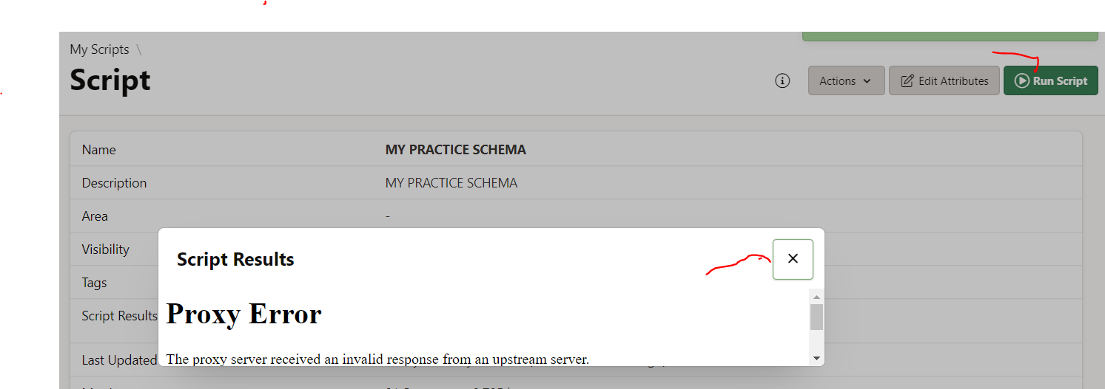

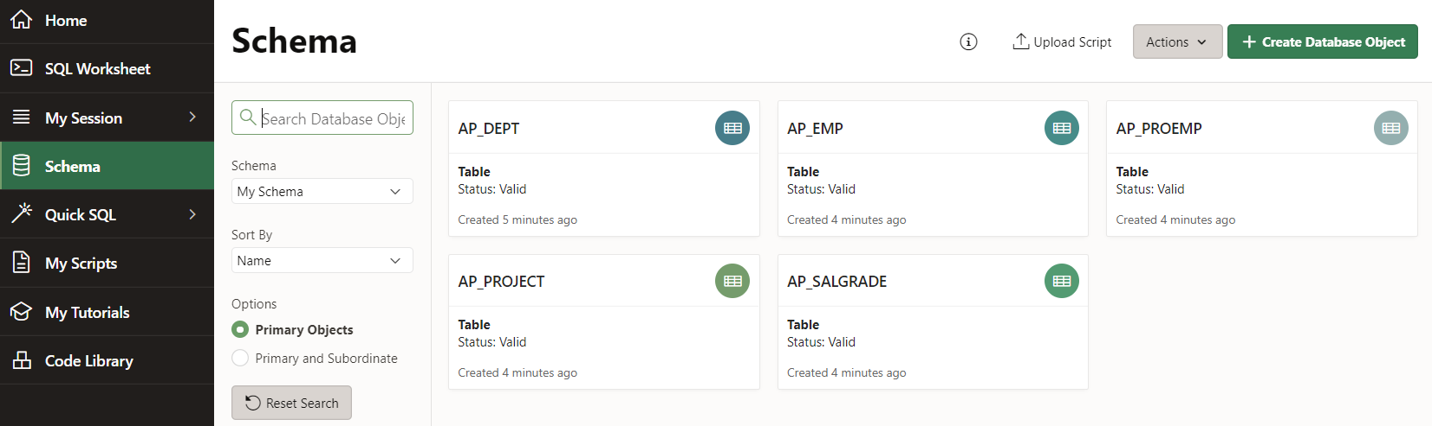

**Step 5:**

**Practice on SQLs from following documents, posted in Practice Tutorial folder.**

SQL_TUTORIAL.docx

Oracle_ROLLUP_CUBE_Examples.docx

Oracle_Analytics_Function_Examples.docx